*About keyestudio

Keyestudio is a best-selling brand owned by KEYES Corporation. Our product contains Arduino development boards, expansion boards, sensors and modules, Raspberry Pi, micro: bit expansion boards as well as smart cars, which can help customers at any level to learn about Arduino , Raspberry Pi and micro: bit.

Notably, all of our products are in line with international quality standards and are greatly appreciated in a variety of different markets across the world.

Welcome to check out more contents from our official website: [**http://www.keyestudio.com**](http://www.keyestudio.com/)

*Obtain Information and After-sales Service

1. Download address：https://fs.keyestudio.com/KS3029
2. If something is found missing or broken, or you have some difficulty learning the kit, please feel free to contact us. Welcome to send email to us：[**service@keyestudio.com**](http://m.138.gz.cn/webadmin/~CAmsnCrrNXhTAySKCerrIfWjjZuuWVfI/~/usr/mod_edituser.jsp?;uid=service@keyestudio.com;;clearCache=)**.**
3. We will seek to update projects and products continuously from your sincere advice.

*Warning

1. This product contains tiny parts(screws, copper pillars), please keep it out of reach of children under 7 years old.
2. This product contains conductive parts (control board and electronic module). Please operate according to the requirements of tutorials. Improper operation may cause parts to overheat damage. Do not touch and immediately disconnect the circuit power.

*Copyright

The keyestudio trademark and logo are the copyright of KEYES DIY ROBOT co.,LTD. All products under Keyestudio brand can’t be copied, sold and resold without authorization by anyone or company. If you are interested in

our products, please contact to our sales representatives:

[**fennie@keyestudio.com**](http://m.138.gz.cn/webadmin/~CAmsnCrrNXhTAySKCerrIfWjjZuuWVfI/~/usr/mod_edituser.jsp?;uid=fennie@keyestudio.com;;clearCache=)

# keyestudio 4WD Mecanum Robot For Pico

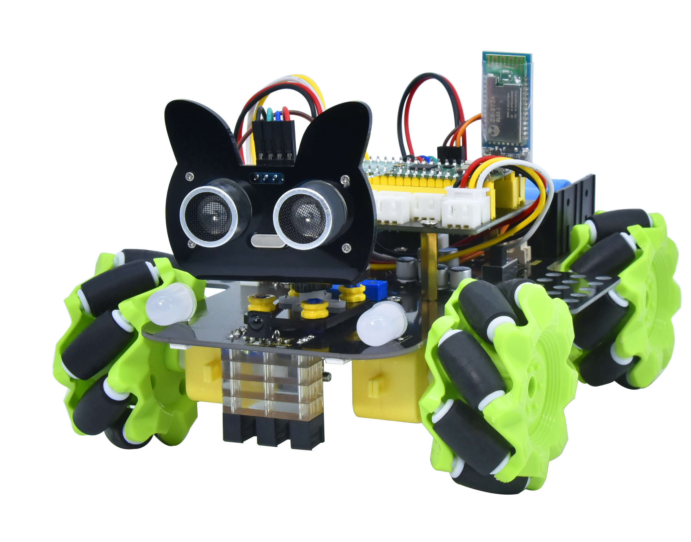

# **Description**

Have you wondered to learn programming or have your own programming robot? Nowadays, programming has developed to a lower age group, and it will be a trend for everyone thanks to the spread of simple graphical programming platforms, from micro:bit to Arduino and Raspberry Pi.

Maybe you haven't heard of them before. However, with the help of this product and tutorial, you can easily install a multi-functional programming 4WD Mecanum car and experience the fun of being a maker.

Raspberry pi pico is a highly integrated microcontroller with powerful functions and small size. It is very suitable to be applied in STEAM education for its functions to make robots, wearable devices and electronic interactive games via the combination of code programming and graphical programming.

This Keyestudio 4WD Mecanum Robot Car For Pico is a smart DIY car dedicated to Raspberry Pi Pico. The smart car consists of a car body with extended functions, a PCB base plate with integrated motor driver sensors, 4 decelerating DC motors, Mecanum wheels, RGB lights, various sensors as well as acrylic boards. Therefore, you can easily assemble a cool Mecanum wheel 4WD smart car by yourself.

We made two tutorials for the car, one is for C language using Arduino IDE

and the other is for MicroPython using Thonny IDE, which will guide you to

enjoy installation and programming. In this process, not only can you enhance your ability to make stuffs but also learn the skills of programming.

Python is one of the most popular programming languages especially in machine learning for its availability and accessibility have brought huge convenience. However, MicroPython is committed to reviving the Python programming language in microcontrollers and embedded systems, while C language empowers us to get to the lower-level code.

This is a C language tutorial for 4WD Mecanum Robot Car For Pic and the code in this tutorial is written in C/C++. Each project code is explained in detail, making it more accessible for you to understand them.

In closing if you have any difficulties or questions with this tutorial and toolkit, you can consult us at any time.

1. **Features**

This product integrates a host of functions such as seven-color lights, WS2812RGB LEDs, servo, ultrasonic, line tracking, IR control as well as Bluetooth control. Among them, the seven-color lights, RGB2812 LEDs, motor drivers, 3-channel line tracking sensor, IR receivers (in order to receive accurately, we will place one at the head and one at the tail) are all integrated into the base plate, making it more accessible for us to install.

What’s more, the 4 WS2812RGB LEDs enable to display different colors, and the 2 seven-color lights empower to make direction lights for the car. By the way, the motor speed of this product is adjustable.

This product uses two 18650 lithium batteries for power supply. When installing and disassembling the battery, please pay attention to the positive and negative poles of the battery, and be sure not to reverse them.

# **3. Parameters**

* Connector port input: DC 6V---9V
* Operating voltage of driver board system: 5V
* Standard operating power consumption: about 3W
* Maximum power: 14W
* Motor speed: 200RPM
* Working temperature range: 0-50℃
* Dimension: 134*181*75mm
* Environmental protection attributes: ROHS

# Kit

|  |  |  |  |
| --- | --- | --- | --- |
| # | Picture | Components | QTY |
| 1 |  | Acrylic Board | 1 |
| 2 |  | Acrylic Board with Lego Holes | 1 |
| 3 |  | Motor Plate | 4 |
| 4 |  | Motor | 4 |
| 5 |  | Fixing Board | 4 |
| 6 |  | Servo | 1 |
| 7 |  | Bluetooth Module | 1 |
| 8 |  | Mecanum Wheels (A direction) | 2 |
| 9 |  | Mecanum Wheels (B direction) | 2 |
| 10 |  | Raspberry Pi Pico | 1 |
| 11 |  | Keyestudio Sensor Shield | 1 |
| 12 |  | Keyestudio Mecanum Car Base Board | 1 |
| 13 |  | M3*20MM Dual-pass Copper Pillar | 4 |
| 14 |  | 4265c Lego Part | 4 |
| 15 |  | 43093 Lego Part | 4 |
| 16 |  | Acrylic Gasket | 1 |
| 17 |  | M3*6MM Flat Head Screw | 10 |
| 18 |  | Ultrasonic Sensor | 1 |
| 19 |  | M3*8MM Flat Head Screw | 10 |
| 20 |  | M3 Nickle-plated Nut | 10 |
| 21 |  | M3*30MM Round Head Screw | 9 |
| 22 |  | M2 Nickle-plated Nut | 3 |
| 23 |  | M2*8MM Round Head Screw | 3 |
| 24 |  | M1.4 Nickle-plated Nut | 6 |
| 25 |  | M1.4*10MM Round Head Screw | 6 |
| 26 |  | M2.5*14MM Round Head Screw | 4 |
| 27 |  | IR Remote Control | 1 |
| 28 |  | Plastic String 3*100MM | 5 |
| 29 |  | USB Cable | 1 |
| 30 |  | HX-2.54 2P DuPont Wire  100mm | 1 |
| 31 |  | XH2.54 5P DuPont Wire  100mm | 1 |
| 32 |  | HX-2.54 4P DuPont Wire 160mm | 1 |
| 33 |  | HX2.54mm-4P to 2.54 F-F DuPont Wire 150mm | 1 |
| 34 |  | XH2.54 3P DuPont Wire 50mm | 2 |
| 35 |  | Screwdriver | 1 |
| 36 |  | TT Coupling | 4 |
| 37 |  | M1.2*5MM Round Head Self-tapping Screw | 6 |

1. **Project Contents**

Project 1：Seven-Color LED Flash

Project 2: WS2812RGB

Project 3: Servo

Project 4: Motor

Project 5: Line Tracking Sensor

Project 6: Line Tracking Smart Car

Project 7: Ultrasonic Sensor

Project 8: Ultrasonic Following Smart Car

Project 9: Ultrasonic Avoidance Smart Car

Project 10: IR Remote Control

Project 11: IR Remote Control Smart Car

Project 12: Bluetooth Control Smart Car